

| **TITLE: Using virtual labs to understand the concept of matrix multiplication and call by reference** |
| --- |

**AIM:** Use of virtual labs to understand the concept of matrix multiplication and call by reference, theory with examples and verify the same with practice questions. **______________________________________________________________________Expected OUTCOME of Experiment:** The first program inputs 2 matrices from the user, multiplies both the matrices and gives their product matrix as the output. The second program swaps two numbers, using the ‘call by reference’ method. **_____________________________________________________________________**

**Books/ Journals/ Websites referred:**

1. Programming in ANSI C, E. Balagurusamy, 7 th Edition, 2016, McGraw-Hill Education, India.
2. Structured Programming Approach, Pradeep Dey and Manas Ghosh, 1 st Edition, 2016, Oxford University Press, India.
3. Let Us C, Yashwant Kanetkar, 15th Edition, 2016, BPB Publications, India.

**_____________________________________________________________________**

**Problem Definition:**

Virtual Lab experiment on matrix multiplication

<https://cse02-iiith.vlabs.ac.in/exp/arrays/simulation.html>

Program to multiply 2 matrices (2-dimensional arrays).

Virtual Lab experiment on Call by reference

<https://cse02-iiith.vlabs.ac.in/exp/pointers/procedure.html>

Program to swap two numbers without using a third variable but by using ‘call by reference’.

**Simulation screenshots:**

For program 1:

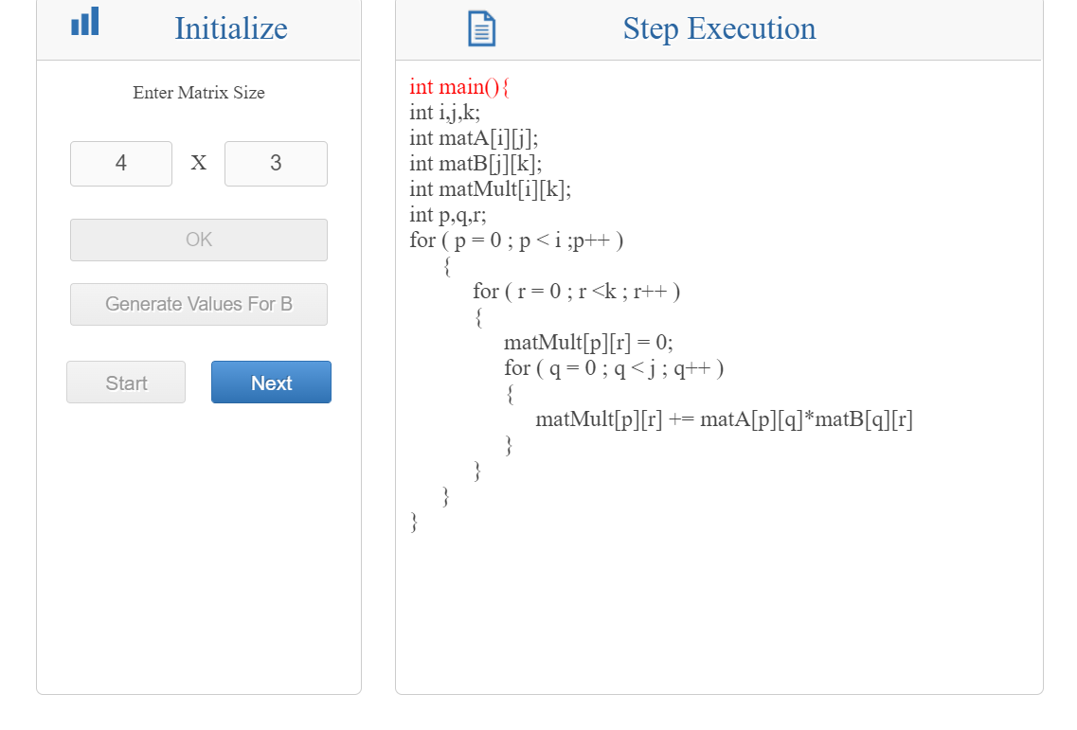

For program 2:

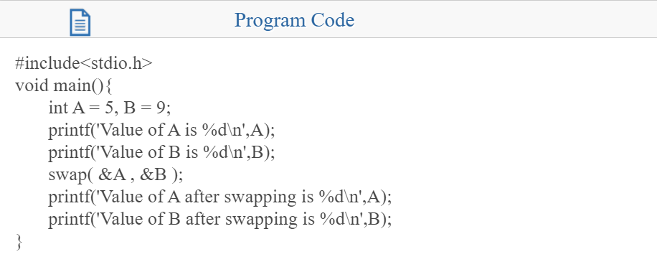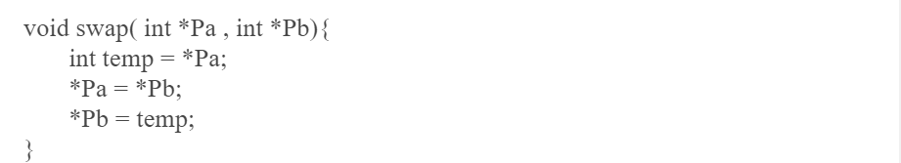

**Post-test Screenshots:**

For program 1:

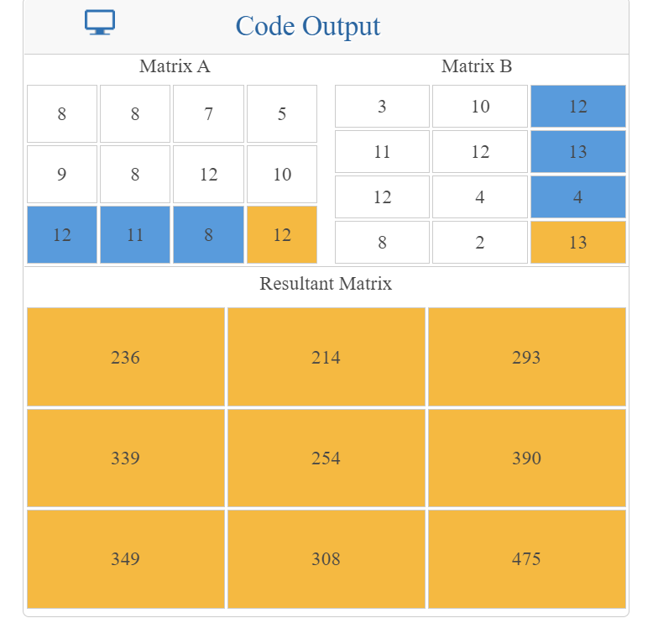

For program 2:

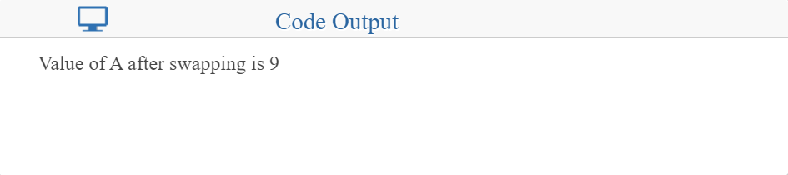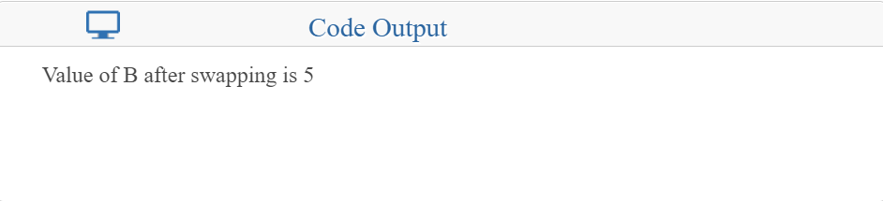**Conclusion and your take away after performing the virtual lab experiment: -**

In the first program, we can infer that operations, in this case multiplication, can thus be performed on matrices after considering them as 2-D arrays. In the second program, we could swap numbers using the ‘call by reference’ method.

**Post Lab Descriptive Questions**

1. **Differentiate between Call by Value and Call by Reference.**

**Ans:** 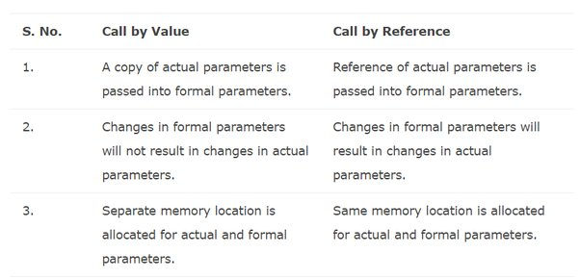

1. **Try to understand the working of pointers by running the following code and noting down the output.**

main( )

{

int i = 3 ;

int *j ;

j = &i ;

printf ( "\nAddress of i = %u", &i ) ;

printf ( "\nAddress of i = %u", j ) ;

printf ( "\nAddress of j = %u", &j ) ;

printf ( "\nValue of j = %u", j ) ;

printf ( "\nValue of i = %d", i ) ;

printf ( "\nValue of i = %d", *( &i ) ) ;

printf ( "\nValue of i = %d", *j ) ;

}

Output:

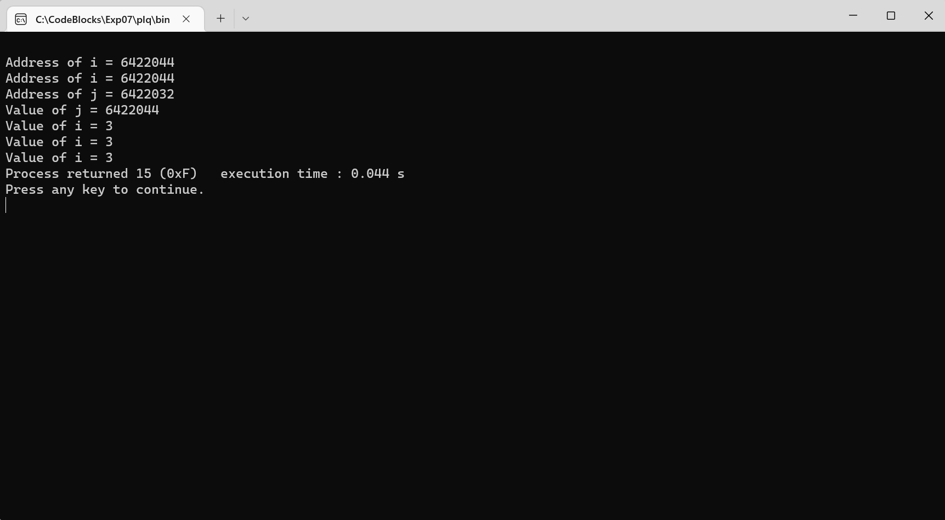

**Date: _____________ Signature of faculty in-charge**